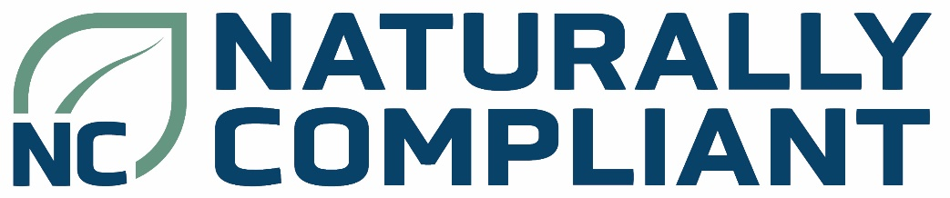

Project Ecologist
Naturally Compliant has an enviable history of providing environmental consultancy services to the construction sector. We work with our clients to deliver the infrastructure and developments across a range of sectors, promoting strong environmental performance while enabling delivery on time and on budget.
The role
You will play a pivotal role supporting our clients in the post planning consent and construction phases – where there is an opportunity to make a real impact on the project’s environmental performance. You will support them in meeting their ecological needs, providing advice, delivering mitigation and undertaking ecological surveys where required.
About you
Experience: We need you to be experienced in delivering onsite construction phase support across a range of ecological disciplines through varying levels of complexity. Are you confident enough to regularly liaise the construction project management team and proactively identify and mitigate any risks to the projects programme, budget, and or deliverability of a project.
Skills: Great interpersonal and communication skills, with an innate ability to persuade and build strong client relationships.
Knowledge: An understanding of the ecological and construction sector.
Attributes: Self-motivated, proactive, solution focussed, and happy to work flexibly.
Commitment: Ready to successfully deliver outstanding support to enable our client to achieve their goals.
Location: Scottish central belt.
Why join us
Impact: Make a tangible difference in promoting sustainable practices within the environmental and construction sectors.
Reward: Our offer is aimed to support you help our clients deliver excellent projects and includes;
- Salary banding of Consultant £30-40k, Senior Consultant £40-50k, Principal Consultant £50-60k and Associate Director £60-70k
- 7% employers pension contribution
- 25 + 8 Holiday allowance
- Health and Wellbeing and Volunteer days
- Private Health insurance
- EV Salary Sacrifice Scheme
- Profit Share Scheme
If you are driven to make a difference and passionate about elevating environmental performance in the environmental and construction sector, we’d like to hear from you.
Apply today
To express your interest, please submit your CV and a brief cover letter outlining your fit for this role to: info@naturallycompliant.com

